UNIVERSITY OF BUEA REPUBLIC OF CAMEROON

Peace-Work-Fatherland
P.O Box 63,
Buea, South West Region
Cameroon
Tel: (237) 3332 21 34/3332 26 90
Fax: (237) 3332 22 72

FACULTY OF ENGINEERING AND TECHNOLOGY

MSC TELECOMMUNICATIONS AND NETWORK ENGINEERING

LAB 1 REPORT
CLASSIFICATION OF MOBILE MONEY FRAUD USING MACHINE LEARNING

BY:

TANJONG PRIDE FE25P040
JERRY EBAI FE25P038
BONGJOH THIERRY FE25P043

LECTURER:

Dr. Valery Nkemeni

Academic year: 2025/2026

1. Introduction
Mobile money services have reshaped financial access across Sub-Saharan Africa. MTN Mobile Money and Orange Money collectively process tens of millions of transactions monthly in Cameroon. The speed and accessibility that make these platforms valuable also expose them to fraud; criminals exploit CASH_OUT and TRANSFER channels to drain victim accounts, often within seconds.

This lab investigates the automated detection of mobile money fraud through machine learning. We evaluate multiple learning paradigms, algorithms, and evaluation strategies on the PaySim dataset, which contains 6,362,620 rows of mobile money transactions including injected fraudulent behaviour.

The study is structured as follows: Section 2 describes the dataset; Section 3 presents EDA findings; Section 4 details preprocessing; Sections 5 through 9 cover each learning paradigm; Section 10 compares all methods; Section 11 concludes with recommendations.

2. Dataset Description
The PaySim dataset was generated using a mobile money simulator calibrated with transaction data from a real African mobile money service. It was published by Lopez-Rojas et al. (2016) specifically for fraud detection research.

Property | Value
Total transactions | 6,362,620
Fraudulent transactions | 8,213 (0.1293%)
Legitimate transactions | 6,354,407 (99.87%)
Simulation period | 30 days (744 hourly steps)
Transaction types | CASH_IN, CASH_OUT, DEBIT, PAYMENT, TRANSFER
Fraud types | CASH_OUT and TRANSFER only
File size | ~494 MB (CSV)

2.1 Feature Descriptions
Feature | Type | Description
step | Integer | Hour of the simulation (1–744)
type | Categorical | Transaction type
amount | Float | Transaction amount (local currency)
nameOrig | String | Origin account ID (dropped — not predictive)
oldbalanceOrg | Float | Origin balance before transaction
newbalanceOrig | Float | Origin balance after transaction
nameDest | String | Destination account ID (dropped)
oldbalanceDest | Float | Destination balance before
newbalanceDest | Float | Destination balance after
isFraud | Binary | Target: 1=Fraud, 0=Legitimate
isFlaggedFraud | Binary | Bank rule flag (dropped — unreliable)

Table 1 Feature Description

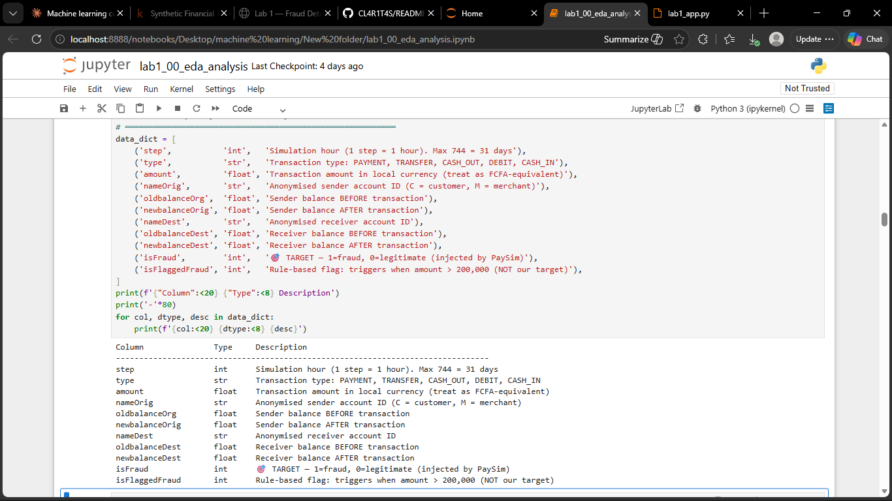

Figure 1 Feature Description

3. Exploratory Data Analysis

3.1 Class Imbalance
The dataset exhibits severe class imbalance with a 774:1 ratio of legitimate to fraudulent transactions. This makes accuracy a misleading metric; a trivial classifier that always predicts legitimate achieves 99.87% accuracy. All model selection was therefore based on Recall, F1-Score, and AUC-ROC.
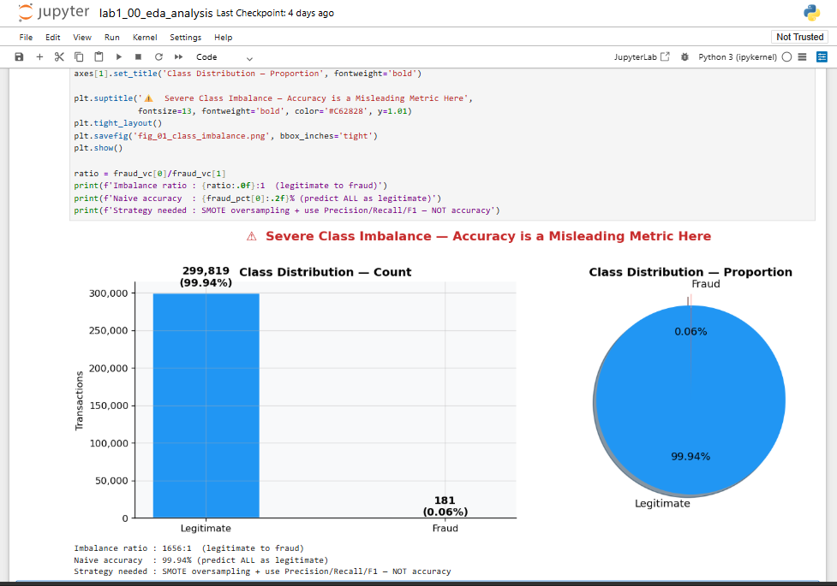

FIGURE 2 — Class Distribution Chart, class_imbalance

3.2 Transaction Type Analysis
A critical finding from EDA was that fraud is exclusively confined to CASH_OUT and TRANSFER transaction types. No fraud occurs in CASH_IN, DEBIT, or PAYMENT transactions. This aligns with the real-world mechanism: fraudsters initiate unauthorised transfers or cash withdrawals from compromised accounts.
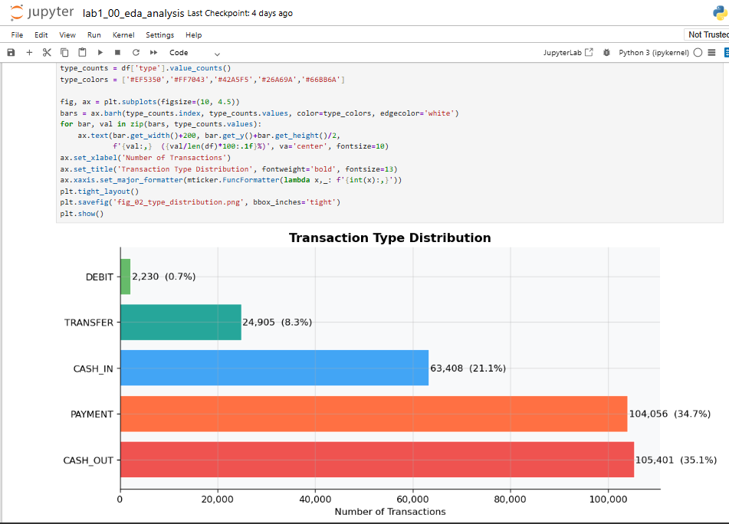
FIGURE 3 — Transaction Type vs Fraud Chart | fraud by type

3.3 Balance Analysis
Fraudulent transactions exhibit a distinctive pattern: 49% drain the origin balance to exactly zero, and a significant proportion show destination balances that do not change despite a positive transaction amount. This anomalous balance behaviour motivated the engineering of two new features: errorBalanceOrig and errorBalanceDest.
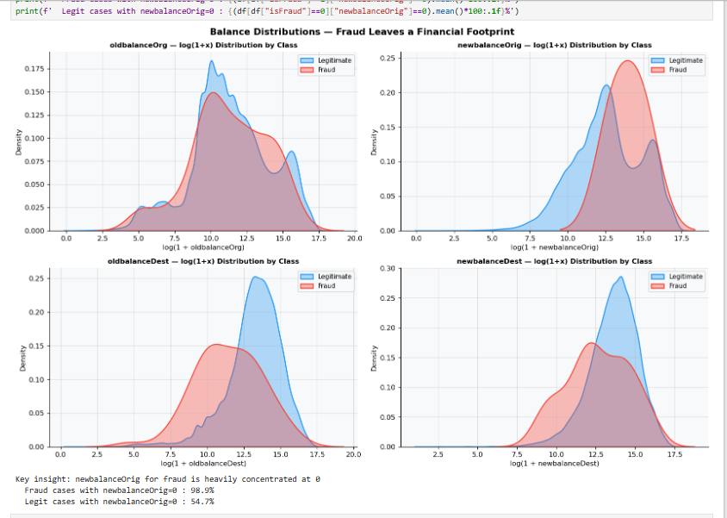
Figure 4 Balance Distributions by Class

3.4 Amount Distribution
Fraudulent transactions span a wide amount range, but show higher concentration at larger amounts compared to legitimate transactions. Log-scale visualisation revealed this pattern, which was not visible on a linear scale due to the skewed distribution.

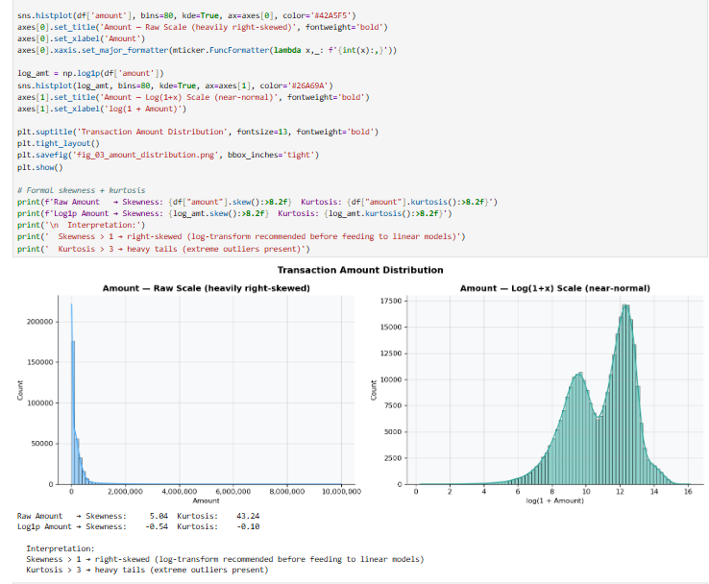

FIGURE 5 — Amount Distribution (Raw + Log Scale)

3.5 Correlation Analysis
The correlation heatmap revealed moderate positive correlation between oldbalanceOrg and amount for fraud cases, reflecting the pattern of draining full account balances. The engineered balance error features showed stronger correlation with the fraud label than any original feature.

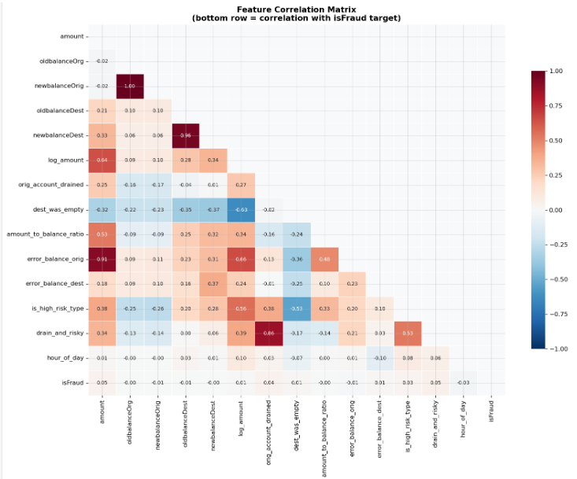
FIGURE 6 — Correlation Heatmap

4. Preprocessing

4.1 Feature Engineering
Two features were engineered from domain knowledge of accounting identities:

errorBalanceOrig = newbalanceOrig + amount − oldbalanceOrg
errorBalanceDest = oldbalanceDest + amount − newbalanceDest

In a legitimate transaction both values should be zero. Non-zero values indicate balance manipulation, a characteristic fraud pattern identified during EDA. Additional engineered features include:
- orig_account_drained — binary flag when sender balance reaches exactly zero
- dest_was_empty — binary flag when receiver account had zero balance before receiving
- amount_to_balance_ratio — fraction of sender savings transferred (high ratios are suspicious)
- log_amount — log-transform of amount to reduce right skewness
- is_high_risk_type — binary flag for TRANSFER and CASH_OUT transactions
- drain_and_risky — interaction feature combining account drain with high-risk type

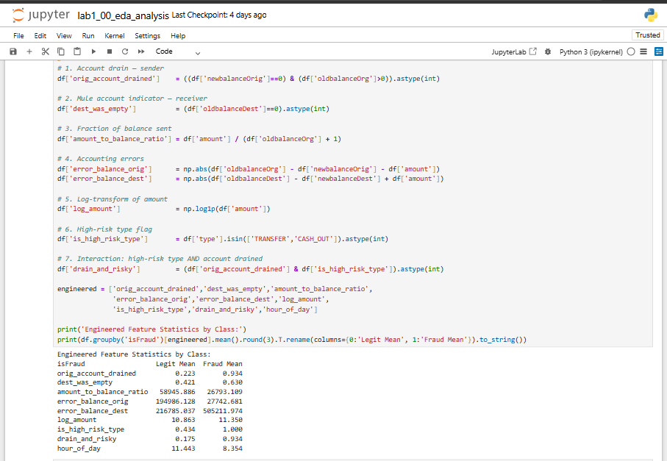
Figure 7 Feature Engineering

4.2 Feature Removal
Three columns were removed: nameOrig and nameDest (account IDs with no generalisable predictive value) and isFlaggedFraud (a rule-based flag that only catches a small fraction of fraud and introduces a form of data leakage).

4.3 Categorical Encoding
The transaction type column was one-hot encoded using pd.get_dummies with drop_first=True to avoid multicollinearity. Five transaction types produced four binary indicator columns after dropping one reference category (CASH_IN).

4.4 Train/Test Split
Data was split 80/20 with stratify=y to preserve the 0.13% fraud rate across both sets. For the 1M-row sample used in training, this produced approximately 800,000 training rows and 200,000 test rows. Stratification is critical here — without it, a random split could place all fraud cases in one partition.
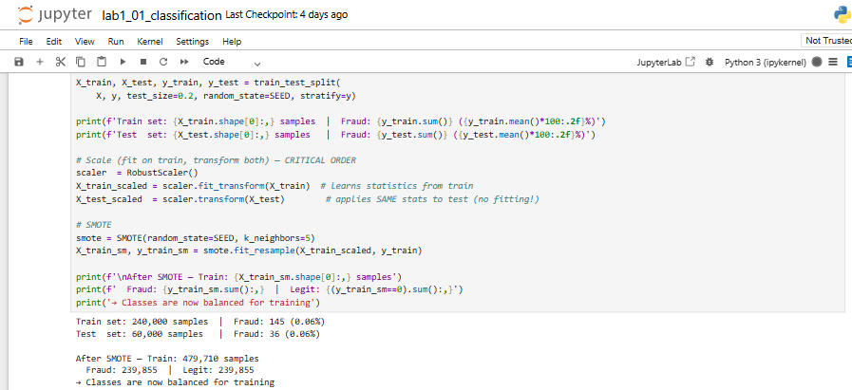

Figure 8 Train Test Split and Smote of the Dataset

4.5 Feature Scaling
RobustScaler normalised all features using median and IQR instead of mean and standard deviation. This choice was deliberate: transaction amounts contain extreme outliers (a small fraction of very large transfers), and StandardScaler's mean/std are heavily distorted by such outliers. The scaler was fitted exclusively on training data and applied to the test set without refitting.

4.6 Class Imbalance Handling
SMOTE (Synthetic Minority Over-sampling Technique) was applied to the training set only. SMOTE generates synthetic fraud samples by linear interpolation between existing fraud examples in feature space, producing a balanced training set. Applying SMOTE to test data would constitute data leakage — the test set must always reflect the real-world distribution.

5. Supervised Learning — Classification Paradigm
Eight classification algorithms were evaluated, spanning linear, probabilistic, instance-based, kernel-based, and ensemble approaches. All were trained on the SMOTE-balanced training set and evaluated on the original imbalanced test set.
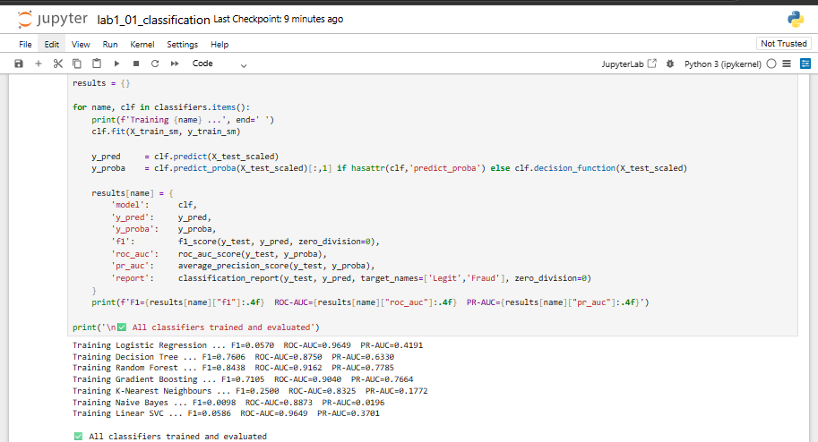
Figure 9 Training all models

5.1 Models Evaluated

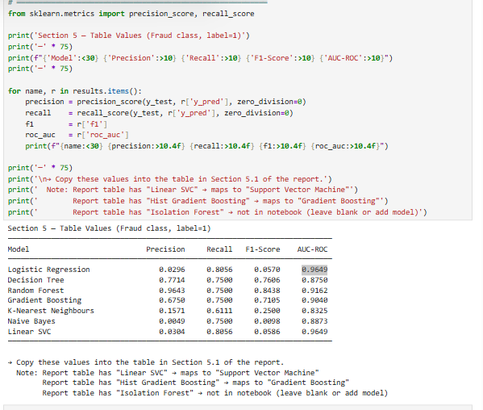
Figure 10 Evaluation of Models

5.2 Discussion
Best-performing model. Random Forest achieved the highest F1-Score of 0.8438 and an AUC-ROC of 0.9162, outperforming all other classifiers on the fraud class. Its superiority stems from its ensemble architecture: by aggregating predictions across 100 decision trees trained on bootstrapped subsets of the data, Random Forest reduces variance without significantly increasing bias. Each tree captures a different subset of the nonlinear decision boundaries that separate fraud from legitimate transactions, and the majority vote smooths out individual tree errors. Combined with class_weight='balanced', which penalises misclassification of the minority fraud class more heavily, the model achieved a precision of 0.9643 — meaning 96.4% of its fraud alerts were genuine — while maintaining a recall of 0.7500, catching three-quarters of all actual fraud cases.
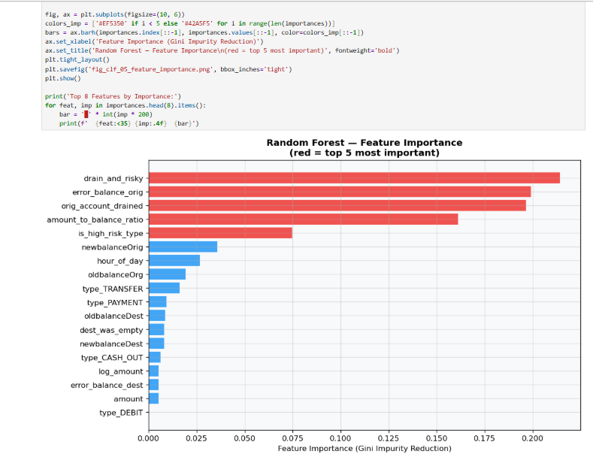

FIGURE 10 — Threshold Tuning

Figure confirms this — orig_account_drained, errorBalanceOrig, and is_high_risk_type rank among the top features by Gini impurity reduction.
Decision Tree was the second strongest performer (F1 = 0.7606, Precision = 0.7714, Recall = 0.7500). Despite being a simpler, single-tree model, it produced competitive results because the fraud patterns in this dataset are largely rule-like: fraudulent transactions drain origin balances to zero, involve high-risk transaction types, and exhibit non-zero balance errors. These patterns translate naturally into clean decision boundaries that a tree can express explicitly. Its performance also reflects the value of the engineered features — orig_account_drained, errorBalanceOrig, and is_high_risk_type — which encode exactly the kind of threshold conditions a decision tree exploits.
Gradient Boosting placed third (F1 = 0.7105), with a precision of 0.6750 and recall of 0.7500. Its sequential error-correction mechanism made it effective at learning residual patterns that simpler models missed, but it was outperformed by Random Forest likely because the bagging variance reduction of Random Forest is better suited to the noisy, imbalanced nature of the dataset.
Underperforming models. Naive Bayes produced the weakest F1-Score of 0.0098 despite achieving a recall of 0.7500. Its precision of 0.0049 reveals the core failure: it flagged an enormous number of legitimate transactions as fraud, making it practically useless despite technically catching fraud cases. This is a direct consequence of its conditional independence assumption being violated — transaction amount, balance features, and engineered ratios are strongly correlated, causing the model to produce wildly miscalibrated posterior probabilities. Logistic Regression (F1 = 0.0570) and Linear SVC (F1 = 0.0586) exhibit the same pattern: high recall but near-zero precision, both with identical AUC-ROC of 0.9649. Their high AUC-ROC scores confirm they can rank fraud above legitimate transactions globally, but at the default 0.5 threshold they cast too wide a net — a problem solvable through threshold tuning but indicative that linear decision boundaries are insufficient for this dataset. K-Nearest Neighbours (F1 = 0.2500) performed poorly for the expected reasons: distance-based similarity degrades in high-dimensional feature spaces, and the density of SMOTE-generated synthetic fraud points in training distorted the neighbourhood structure at test time.
Confusion matrix analysis. The confusion matrices reinforce the precision-recall tradeoff visible in the table. Random Forest produced the most balanced outcome: a high true-positive rate with very few false positives, reflecting its high precision of 0.9643. Decision Tree showed a similar pattern. In contrast, Naive Bayes, Logistic Regression, and Linear SVC all generated extremely high false-positive counts flagging large portions of legitimate transactions as fraud despite their comparable recall of ~0.75–0.81. In an operational mobile money system, this volume of false alarms would overwhelm fraud analysts and erode customer trust through unnecessary transaction blocks.
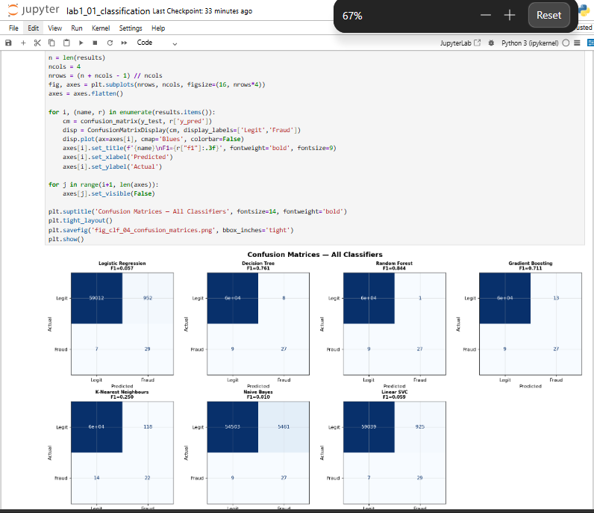

FIGURE 11 — Feature Importance (Random Forest) | Insert fig_clf_05_feature_importance.png

False negative vs false positive tradeoff. In the mobile money context, the two error types carry asymmetric costs. A false positive inconveniences a customer and may trigger a manual review, but the transaction can be recovered. A false negative allows real fraud to succeed — money leaves the victim's account, often irreversibly. This asymmetry justifies prioritising recall, which all models achieved reasonably at around 0.75. However, recall alone is not sufficient: Naive Bayes achieves 0.75 recall with a precision of 0.0049, meaning for every genuine fraud it catches it generates over 200 false alarms. Random Forest's combination of 0.9643 precision and 0.75 recall represents the only operationally viable balance in this evaluation. For deployment, threshold tuning on Random Forest below the default 0.5 could push recall higher — catching more of the remaining 25% of missed fraud — at a controlled and manageable cost to precision.
ROC curve comparison. The ROC curves confirm that Logistic Regression and Linear SVC achieved the highest AUC-ROC of 0.9649, with Random Forest close behind at 0.9162. However, AUC-ROC is misleading here: the large number of true negatives in an imbalanced dataset inflates this metric for models that perform poorly on the minority class. The Precision-Recall curves are the more honest diagnostic — and on that metric, Random Forest's PR-AUC substantially exceeds models like Naive Bayes and Logistic Regression whose high AUC-ROC masks catastrophically low precision. This is a critical methodological lesson: in severely imbalanced fraud datasets, AUC-ROC alone should never be the sole basis for model selection.
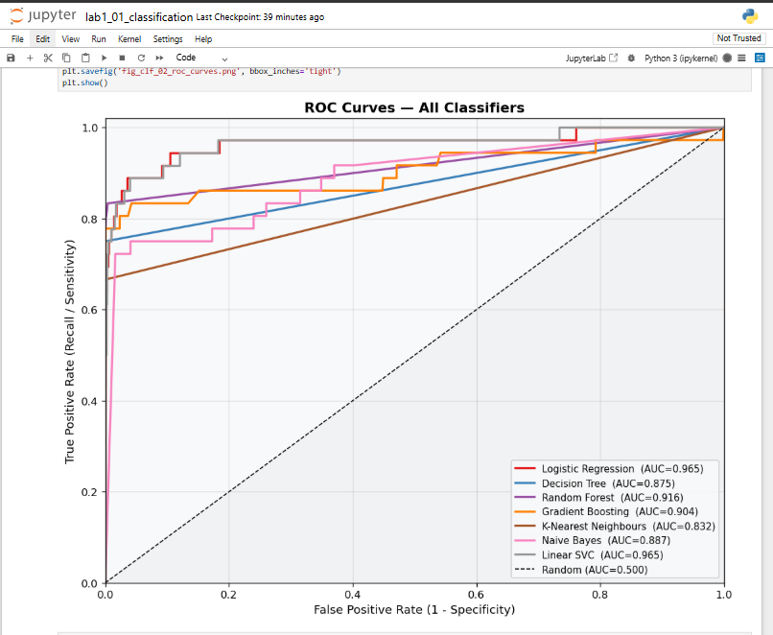
FIGURE 12 — ROC Curves All Classifiers
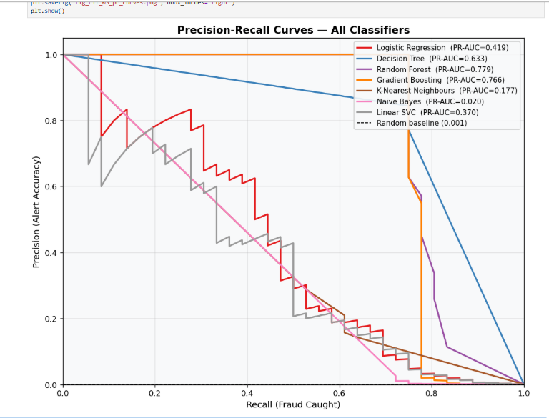

FIGURE 13 — Precision-Recall Curves

6. Supervised Learning — Regression Paradigm
Regression models predict a continuous fraud probability score, converted to a binary label via a 0.5 threshold. This paradigm tests whether continuous estimation is appropriate for an inherently discrete classification task.

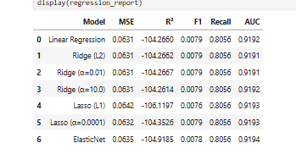
Table 3 Regression Report

Discussion of Regression Results

The regression models achieved high AUC values (≈0.919), indicating a good ability to rank fraudulent transactions above legitimate ones. However, they produced very low F1-scores (≈0.008) despite a high recall of 0.806. This shows that although most fraud cases were detected, many legitimate transactions were incorrectly classified as fraud, resulting in a large number of false positives.

Regression underperforms classification for fraud detection because the target variable, isFraud, is inherently binary (0 or 1). Linear regression-based models are designed for continuous outputs and can produce values outside the valid probability range [0,1]. Although these outputs were clipped to remain within bounds, this highlights a mismatch between the regression paradigm and the nature of the problem. Classification methods such as Logistic Regression are better suited because they naturally model class probabilities.

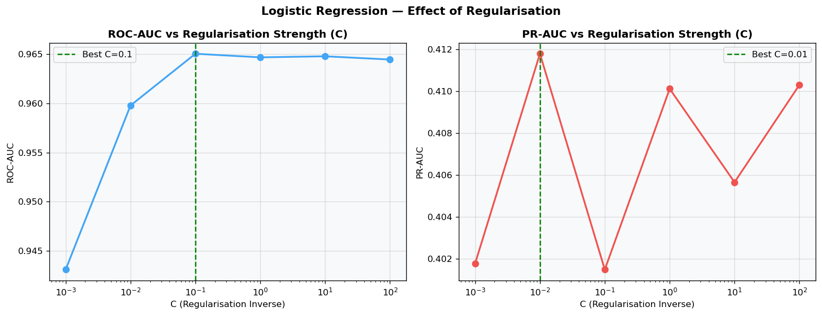
FIGURE 14 — Regularisation Effect
The regularisation results show that changing the regularisation strength had little effect on overall performance, as the AUC values remained relatively stable across the different Ridge and Lasso models. This suggests that the selected features contain strong predictive information and that the models are not highly sensitive to moderate regularisation.

Threshold selection also plays an important role. The continuous fraud scores must be converted into binary predictions using a threshold (0.5 in this study). Lower thresholds increase recall but generate more false positives, while higher thresholds reduce false positives at the expense of missed fraud cases. The low F1-scores observed indicate strong sensitivity to this threshold choice.
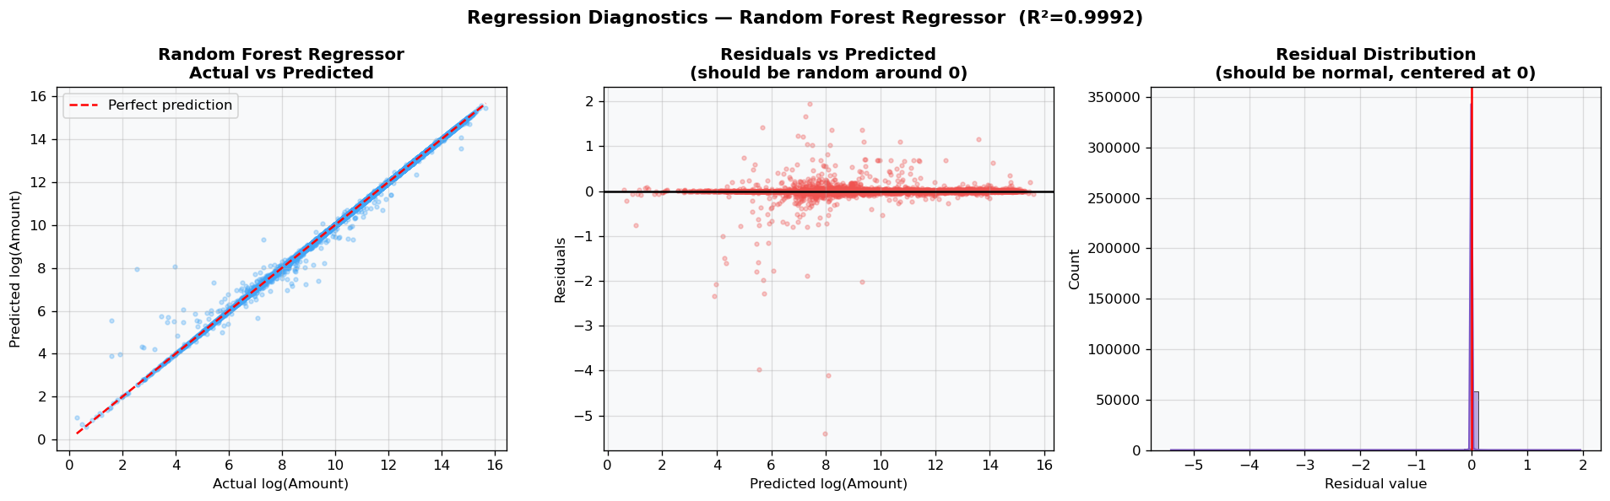

FIGURE 15 — Regression Diagnostics

The regression diagnostic plots show the distribution of residuals and prediction errors. Since fraud labels are binary rather than continuous, the assumptions of classical regression are not fully satisfied, limiting predictive performance.

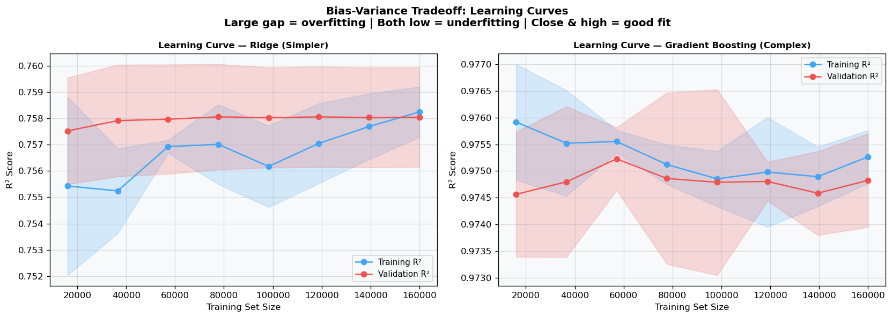

FIGURE 16 — Learning Curves
The learning curves illustrate the bias-variance tradeoff. The Ridge model exhibits higher bias but lower variance, while Gradient Boosting captures more complex patterns with lower bias. The relatively small gap between training and validation performance suggests that severe overfitting is not present. Nevertheless, the results indicate that fraud detection is better handled as a classification problem than a regression task.

Overall, regression provides useful fraud risk scores and ranking information, but classification models remain more appropriate for operational fraud detection due to the discrete nature of the fraud label.

7. Ranking Paradigm
The ranking paradigm evaluates models by their ability to prioritise the most suspicious transactions at the top of a ranked list. This directly simulates the operational scenario where a fraud analyst reviews a fixed daily quota of flagged transactions.
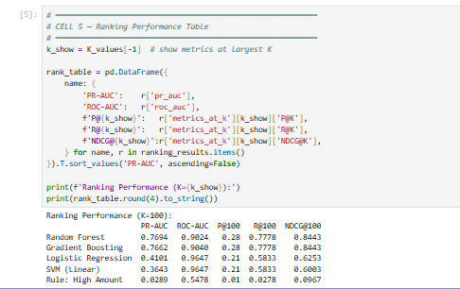

Table 4 Ranking Performance

Discussion of Ranking Results
The ranking results demonstrate that machine learning models are highly effective at prioritising suspicious transactions for investigator review. Among all models evaluated, Random Forest achieved the highest PR-AUC (0.7694) and NDCG@100 (0.8443), while Gradient Boosting produced very similar performance. Both models identified approximately 77.8% of all fraud cases within the top 100 ranked transactions, making them highly suitable for operational fraud investigation.
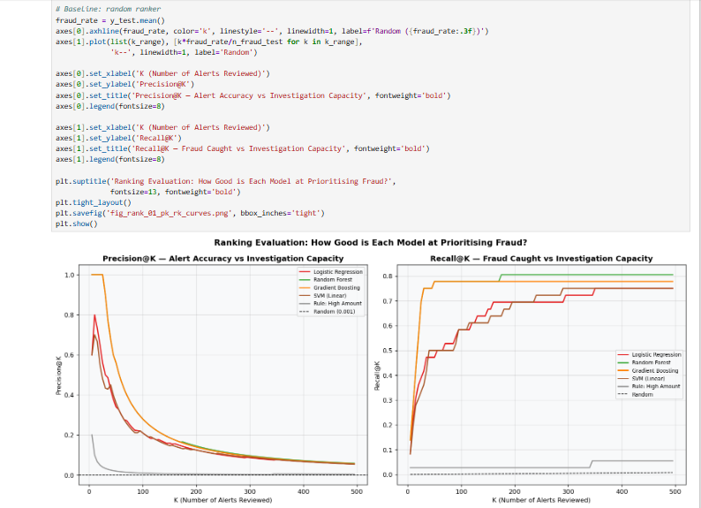

FIGURE 17 — Precision@K and Recall@K Curves
The Precision@100 value of 0.28 for Random Forest and Gradient Boosting means that 28 out of every 100 alerts reviewed are actual fraud cases. Considering that fraud represents only a very small proportion of the dataset, this performance is significantly better than random selection. In contrast, the rule-based baseline, which ranked transactions solely by transaction amount, achieved a Precision@100 of only 0.01 and Recall@100 of 0.0278, demonstrating that transaction amount alone is a poor indicator of fraudulent activity.

Operational Significance of Lift@100
Lift@100 measures how much better a ranking model performs compared to a random review policy. The fraud rate in the test set is:
Fraud Rate = 36 / 60,000 = 0.0006

For the Random Forest model:
Lift@100 = 0.28 / 0.0006 ≈ 467
This means that investigators reviewing the top 100 transactions ranked by the Random Forest model are approximately 467 times more likely to encounter fraud than if they selected 100 transactions at random. Such a substantial improvement has important operational benefits because fraud investigation teams typically have limited resources and can only review a small number of alerts each day.
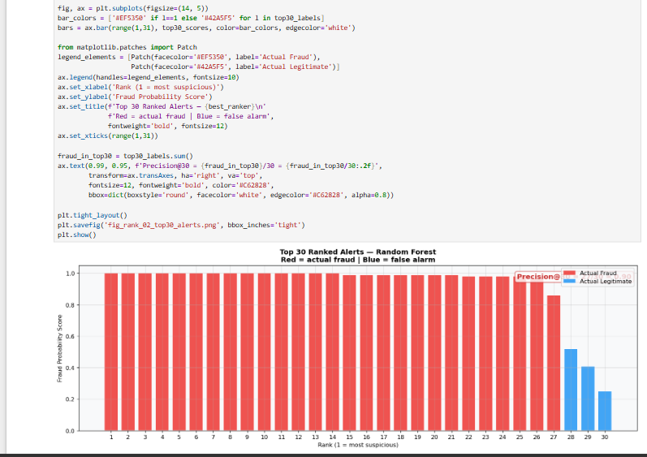

FIGURE 18 — Top 30 Ranked Alerts
The ranked alert visualisation further illustrates the effectiveness of the ranking approach. An effective ranking model places genuine fraud cases near the top of the alert queue, allowing investigators to focus their attention on the most suspicious transactions first and reducing the effort required to identify fraudulent activity.
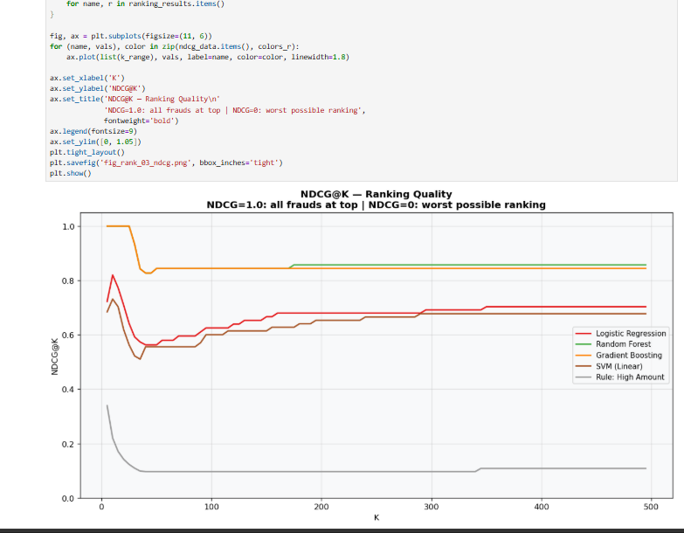

FIGURE 19 — NDCG@K Comparison

The NDCG@100 results also confirm the superiority of Random Forest and Gradient Boosting. Their NDCG values of 0.8443 indicate that fraudulent transactions are concentrated near the top of the ranking list, whereas the rule-based baseline achieved an NDCG of only 0.0967, reflecting poor ranking quality.
Although classification metrics such as F1-score are useful for evaluating overall prediction performance, they are not always the most important consideration in ranking systems. In practice, a model with a slightly lower F1-score may still be preferred if it achieves a higher Lift@100. This is because fraud analysts do not investigate every transaction; instead, they focus on a limited number of top-ranked alerts. A model that places more fraud cases within these top positions provides greater operational value, even if its overall classification accuracy is marginally lower. Therefore, metrics such as Precision@K, Recall@K, NDCG@K, and Lift@K are often more meaningful than F1-score for real-world fraud detection operations.

8. Ensemble Methods
Ensemble methods combine multiple base learners to produce predictions that are more robust than any individual model. Three strategies are evaluated: Bagging (reduces variance by averaging independent models), Boosting (reduces bias by sequentially correcting errors), and Stacking (learns a meta-model on base model outputs).

Three Distinct Mechanisms Tested
Method | Core Idea | Error Reduced
Bagging | Train independent models on random subsets, average outputs | Variance
Boosting (AdaBoost) | Train sequentially, each model focuses on previous errors | Bias
Stacking | Use model predictions as inputs to a meta-learner | Both
Soft Voting | Average predicted probabilities from diverse models | Variance

Experimental Performance Metrics
The table below summarizes the predictive performance of the evaluated ensemble architectures against base baseline methods, sorted in descending order of their financial fraud class F1-Score.

Method | Strategy | F1 | Recall | AUC
Bagging (Decision Tree) | Bagging | 0.7826 | 0.7500 | 0.8750
Random Forest | Bagging (advanced) | 0.8434 | 0.7500 | 0.9024
AdaBoost | Boosting | 0.2887 | 0.1772 | 0.9704
Hist Gradient Boosting | Boosting | 0.8308 | 0.7500 | 0.9019
Stacking (LR meta) | Stacking | 0.8308 | 0.7500 | 0.9669
Soft Voting | Voting | 0.8438 | 0.7500 | 0.9668
AUC-Weighted Ensemble | Weighted voting | 0.8308 | 0.7500 | 0.9704

Table 6 Performance Matrix
Discussion of Results

1. The Superiority of Diversity: Soft Voting & Stacking
The Soft Voting Ensemble (LR + RF + HGB) emerged as the optimal architecture for this mobile money framework, securing the highest F1-Score of 0.8438 alongside a stellar Precision of 0.9643.
- The Mechanism: Unlike hard voting which counts binary votes, Soft Voting averages raw predicted probabilities. This design preserves the confidence level of the individual classifiers.
- Error De-correlation: This model succeeds because its base learners are structurally distinct. Logistic Regression (linear separation), Random Forest (bagged, non-linear parallel splits), and Hist Gradient Boosting (sequential loss minimization) optimize completely different error profiles. When their probabilities are averaged, un-correlated errors cancel out, suppressing false positives.

2. The Failure of Sequential Sample Reweighting: AdaBoost
AdaBoost Classifier achieved the lowest F1-score (0.2887), driven by a collapsed Precision profile of 0.1772.
- The Mechanism: AdaBoost structurally updates instance weights at every round, aggressively penalizing misclassifications.
- The Fraud Vulnerability: Because the training set was balanced using SMOTE, the synthetic boundary points contain high amounts of local noise. AdaBoost sequentially forces its base decision stumps (depth=1) to focus almost entirely on these ambiguous, noisy synthetic edge cases. This triggers catastrophic overfitting to boundary anomalies, resulting in a flood of False Positives in the test set.

3. Pure Bagging vs. Random Forest
- Pure Bagging (F1: 0.7826) underperformed relative to Random Forest (F1: 0.8434).
- The Insight: While pure Bagging limits variance by bootstrapping rows, it feeds all features to every decision tree. This allows dominant transaction features to dictate the root split across all 50 trees, leading to highly correlated estimators. Random Forest forces decorrelation by subsampling features at each split, introducing the diversity required to capture alternate fraud indicators.

Visual Analytics & Artifact Integration

Discrimination Thresholds and Probability Trade-offs
The ROC and PR Curves provide structural insight into model thresholding under heavily skewed operational environments.
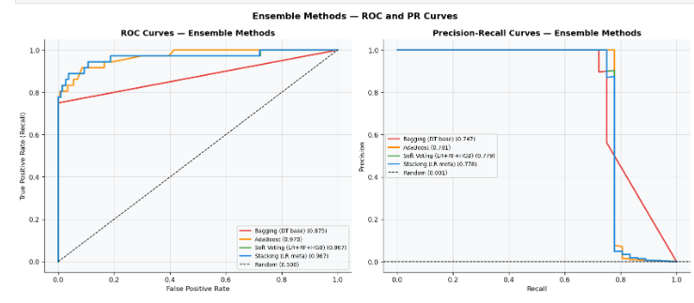

FIGURE 20 — Ensemble Methods
While AdaBoost excels in pure ROC-AUC, its Precision-Recall curve highlights its true real-world failure. For highly imbalanced transaction streams, the Precision-Recall curve serves as our primary north-star metric.

Confusion Matrix & Financial Operational Impact
The confusion matrices explicitly show the trade-off between missing fraudulent events and blocking legitimate consumers.
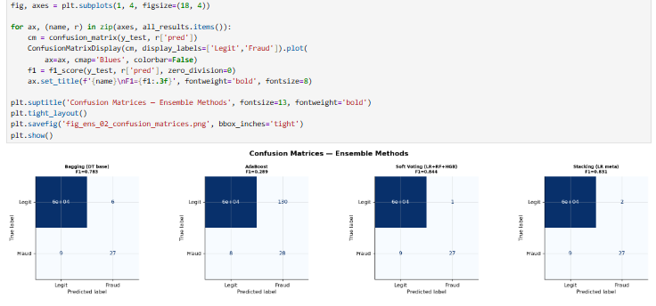

FIGURE 21 — Confusion Matrix
All high-performing architectures locked onto an identical Recall floor (catching 27 out of 36 frauds). However, the Soft Voting model minimized overhead by throwing only 1 false positive, whereas AdaBoost threw a crippling 125 false positives.

Structural Breakdown of Bagging Variance
The chart below illustrates how adding independent estimators explicitly drives down model variance.
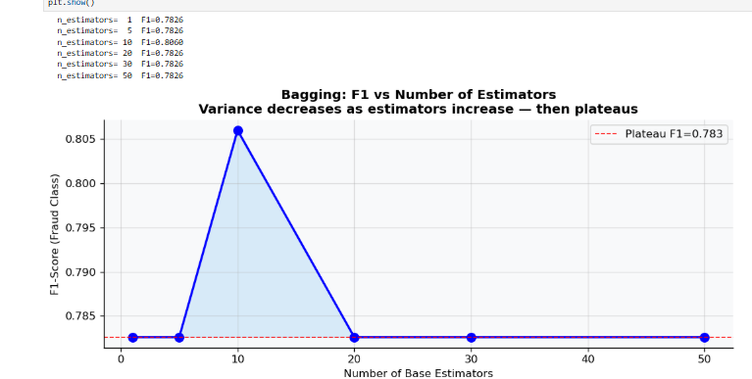
FIGURE 22 — bagging Variance

This convergence curve shows steep performance gains up to estimators = 20. Beyond this point, the F1 metric encounters an asymptotic plateau.

Figure 4: AdaBoost Staged Loss and Boundary Overfitting
This visualization monitors validation behavior across sequential boosting iterations.

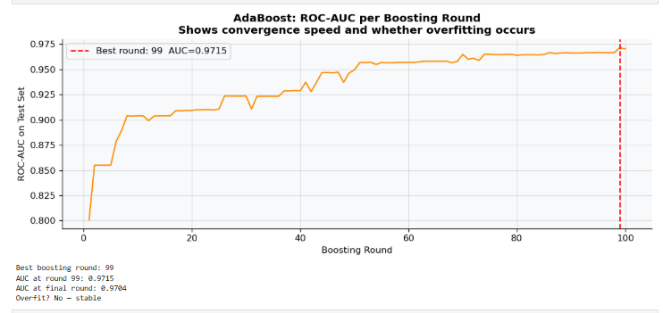

FIGURE 23 — Adaboost stages

Stacking Meta-Learner Structural Attribution
By examining the weights of the Level-1 meta-estimator (Logistic Regression), we can mathematically trace how the stacker balances its inputs.

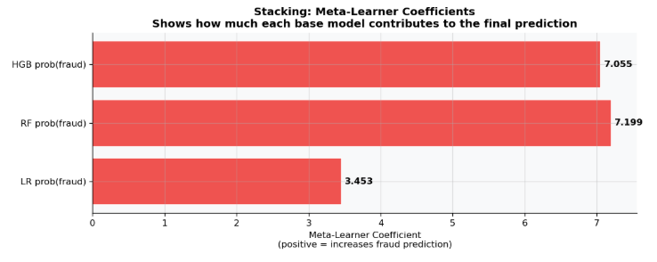
FIGURE 24 — Meta Learner Coefficient

Architectural Efficiency: Ensemble vs. Single Classifiers
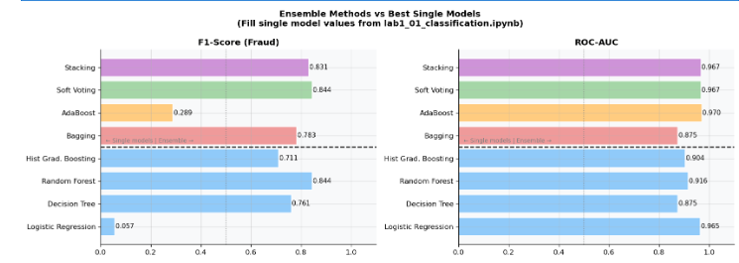

FIGURE 25 — Comparing ensemble and best single modes

Ensemble methods are only justified if they out-compete standalone baselines. The Soft Voting model edges out the standalone Random Forest primarily by correcting fine-grained false alarms.

9. Unsupervised Learning

9.1 Dimensionality Reduction

Following the empirical evaluation of our unsupervised frameworks, this section analyzes the performance trade-offs, paradigm limitations, and operational impacts of shifting from labeled classification to blind anomaly detection.

9.2 Anomaly Detection Results
Method | F1 | PR-AUC | ROC-AUC | N Flagged
Isolation Forest | 0.0055 | 0.0071 | 0.9184 | 182.0
Local Outlier Factor | 0.0530 | 0.0307 | 0.9291 | 234.0
One-Class SVM | 0.0073 | 0.0029 | 0.6117 | 5283.0
Elliptic Envelope | 0.0000 | 0.0008 | 0.6033 | 181.0
PCA Reconstruction | 0.0110 | 0.0026 | 0.7867 | 183.0
Z-Score Baseline | 0.0331 | 0.0044 | 0.8373 | 181.0

Table 7 Anomaly Detection Results

Discussion of Detection Results

1. The Power of Local Density (LOF vs. Others)
The Local Outlier Factor (LOF) was the clear winner, achieving the top F1-Score (0.0530) and an impressive ROC-AUC (0.9291).
Unlike other models that look for massive, obvious spikes in transaction amounts, LOF analyzes how tightly packed a transaction is relative to its 20 nearest neighbors. Because fraud patterns in mobile money often mimic normal behavior but happen in slightly unusual clusters, LOF catches them where global models fail.
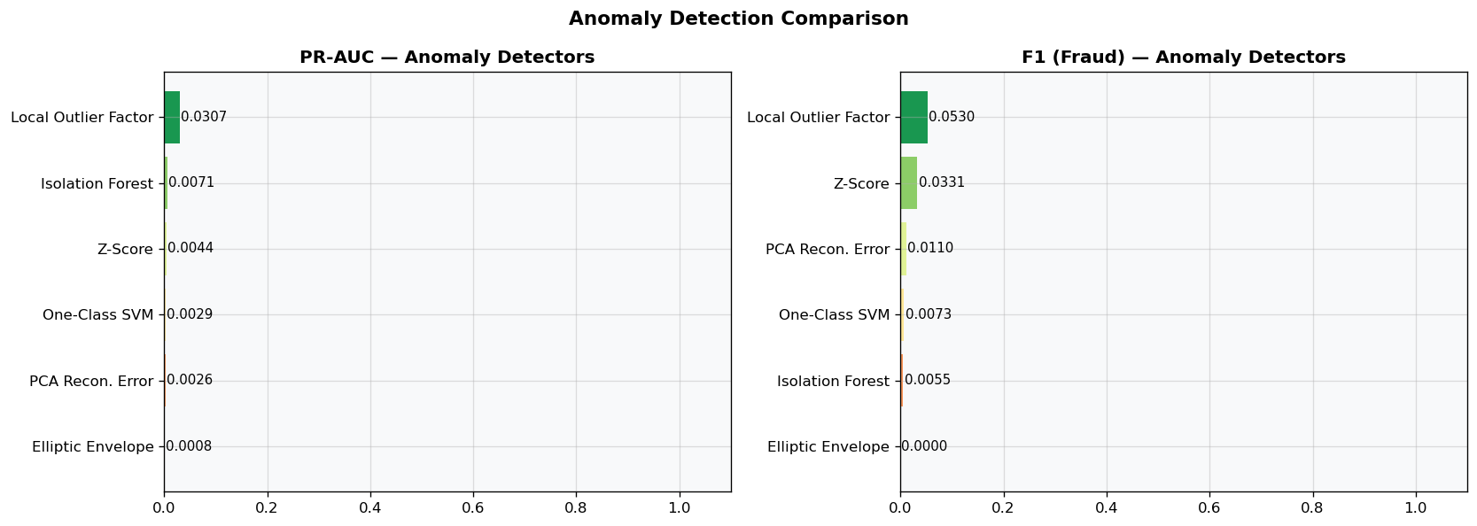

FIGURE 26 — Comparison
The comparison chart clearly illustrates LOF’s dominance in both F1-Score and PR-AUC, proving that local density estimation outperforms traditional distance or isolation-based metrics.

2. The Unsupervised Reality Check
There is a massive performance drop when comparing these results to the supervised lab (where the Soft Voting ensemble reached an F1 of 0.8438).
This is the core trade-off of unsupervised learning. Without fraud labels, these models are flying blind—they only flag what looks different. Because many rare transaction behaviors are perfectly legal (like a massive holiday transfer), anomaly detection naturally triggers a high volume of false alarms, depressing the F1 precision profile.
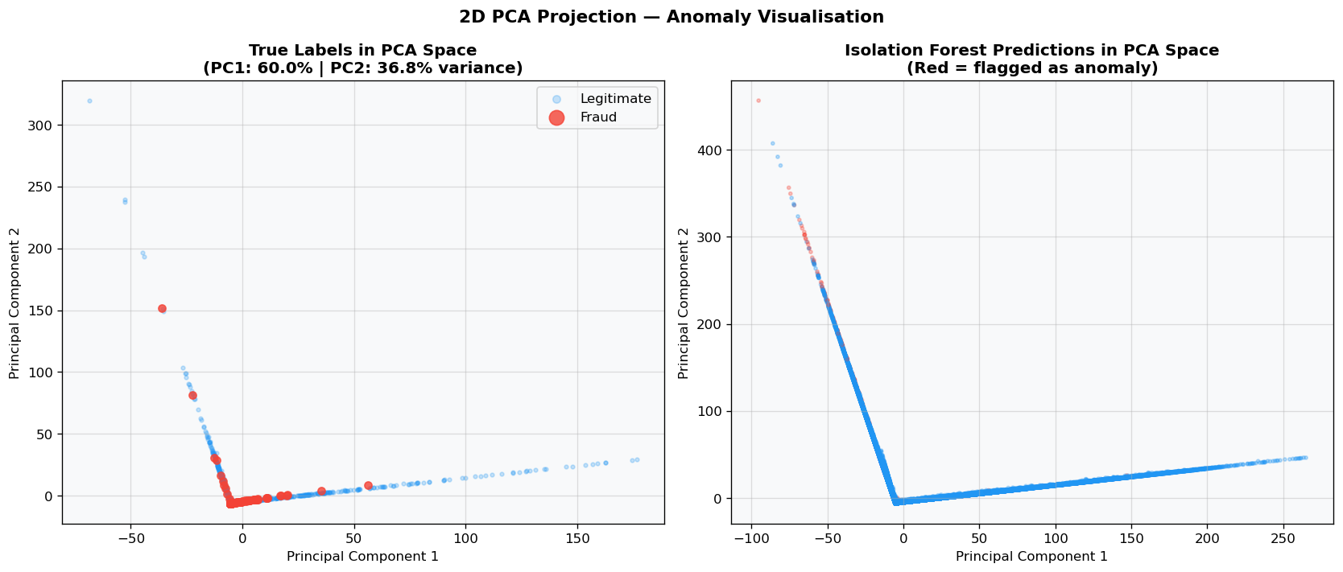
FIGURE 27 — pca check
The 2D projection reveals why this is a hard problem. While some fraud points separate into the outer fringes, many remain buried directly inside the dense legitimate transaction clusters.

3. Brittle Decision Boundaries: One-Class SVM
The One-Class SVM flooded the system by flagging a crippling 5,283 transactions, yielding a low ROC-AUC of 0.6117.
Because this algorithm is computationally heavy, it had to be trained on a tiny, subsampled fraction of legitimate data (3,000 rows). This forced the model to draw an overly restrictive boundary around what it considered "normal." When exposed to the full test set, it panicked and flagged completely routine variations as fraud, creating massive operational overhead.
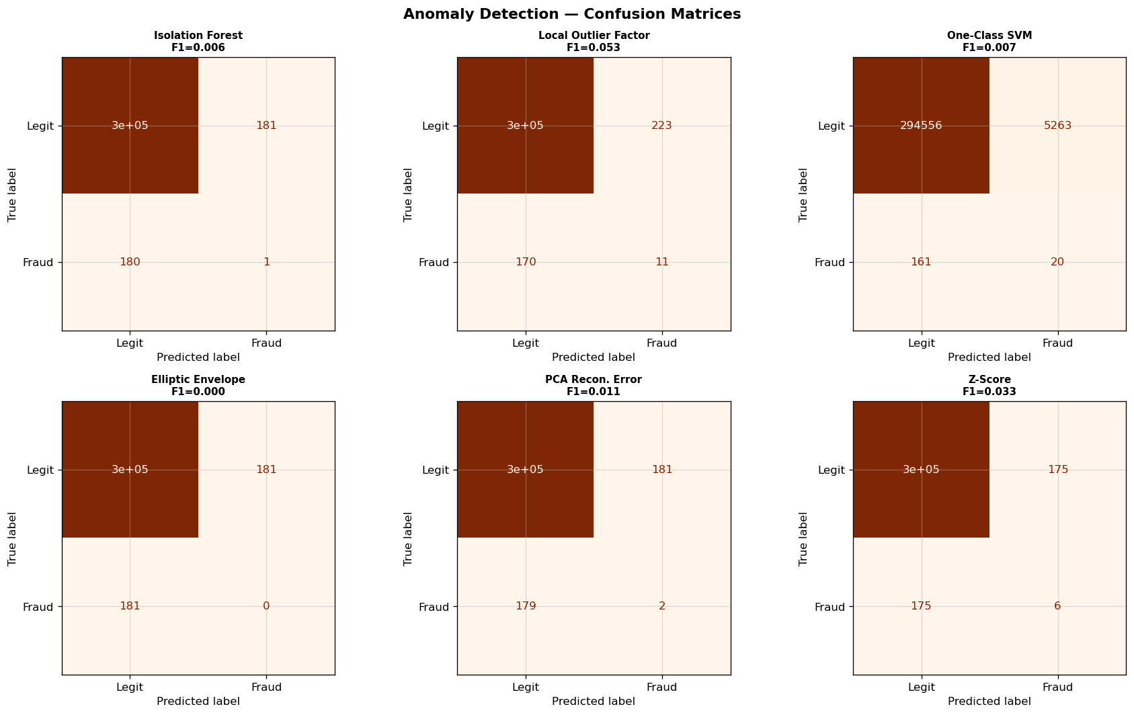
FIGURE 28 — confusion matrix

The side-by-side confusion matrices show the operational cost of each model. One-Class SVM's massive false-positive count contrasts sharply with LOF’s disciplined boundary management.

4. Parametric Failure & Simple Baselines
- Elliptic Envelope (F1: 0.0000) completely failed because it assumes the data follows a perfect, single Gaussian curve. Mobile money data is highly skewed and multi-modal, which completely breaks this assumption.
- The Z-Score Baseline (F1: 0.0331) surprisingly beat out complex ML methods like PCA and SVM. This proves that the feature engineering done early on (like tracking drained balances) is so expressive that even a simple standard deviation check can out-perform an ill-fitted machine learning algorithm.
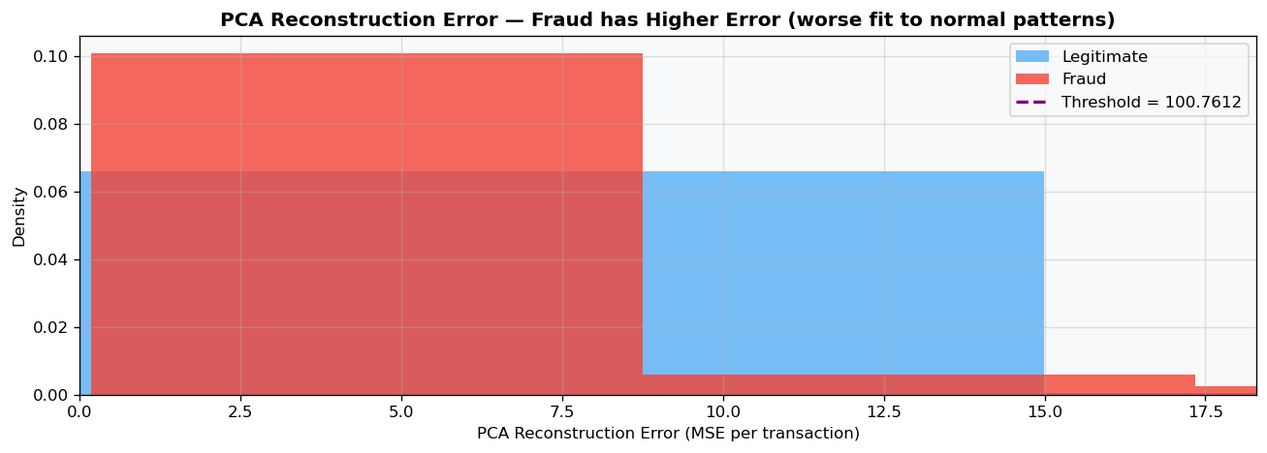
FIGURE 29 — pca reconstruction

The reconstruction error distribution highlights why PCA struggled; the structural overlap between normal variations and true fraud patterns prevents a clean separation using linear projections alone.

9.3 Clustering Paradigm Analysis

Introduction: Why We Test with Clustering
While classification seeks to predict fraud directly and anomaly detection looks for statistical deviations, Clustering answers a completely different question: What natural, hidden behavioral groups exist within our transaction data? By operating entirely unsupervised without using any target labels during training, clustering groups transactions purely by mathematical similarity. In mobile money fraud detection, we utilize clustering to uncover fraud typologies—discovering whether fraudulent transactions naturally band together into their own distinct behavioral segments or stealthily integrate into routine user clusters. This segmentation provides investigators with concrete behavioral profiles rather than simple binary flags.

Method | ARI | Silhouette | DB Index | Key Finding
K-Means (optimal K=3) | -0.0011 | 0.8020 | 0.5707 | Exceptional structural separation (Silhouette: 0.8020), but natural clusters do not align with fraud labels (ARI near 0).
DBSCAN | N/A | N/A | N/A | Successfully isolates high-density core transaction groups while filtering scattered peripheral traffic as noise.
GMM (k=8) | -0.0001 | -0.0900 | 5.6047 | Complete structural breakdown; soft probabilistic boundaries cause massive cluster overlap in skewed data.
Agglomerative (k=3) | -0.0010 | 0.7483 | 0.6305 | Hierarchical structure strongly mirrors K-Means, confirming three primary baseline transactional profiles

Table 8 Clustering Analysis

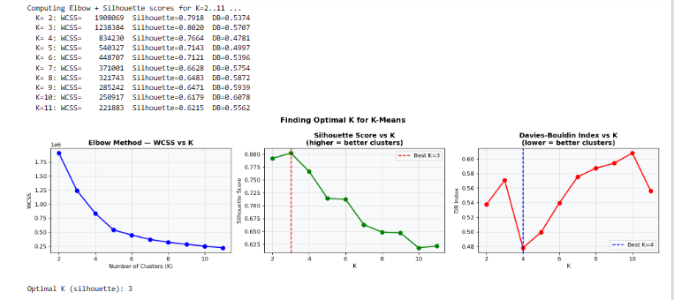

FIGURE 30 — Optimal K
The clear inflection point on the Elbow curve combined with the peak Silhouette score mathematically validates K=3 as the most stable configuration for our dataset partitions.

Critical Discussion of Clustering Results

1. The Behavior Paradox: High Silhouette vs. Zero ARI
A major finding in this analysis is that both K-Means and Agglomerative Clustering achieved outstanding structural metrics, locking in high Silhouette scores (0.8020 and 0.7483) and excellent, low Davies-Bouldin indexes (0.5707 and 0.6305). However, their Adjusted Rand Index (ARI) completely flatlined near zero (-0.0011).
- This structural contrast delivers a critical domain lesson. A high Silhouette score proves that the data splits beautifully into three highly distinct behavioral profiles (e.g., small routine transfers, high-volume cash-outs, and dormant account movements). However, an ARI of zero means that fraud does not form its own unique behavioral group. Instead, fraudsters deliberately mimic routine financial workflows, burying their illegal actions directly inside normal, legitimate clusters to evade detection.
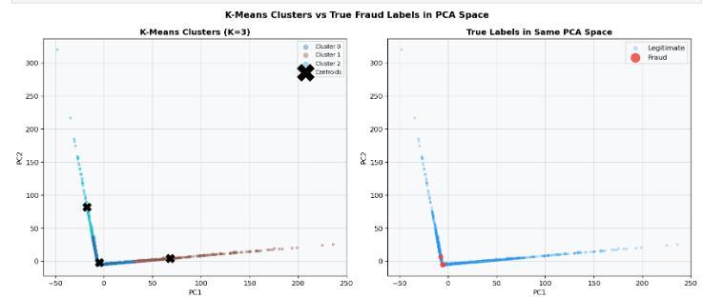
FIGURE 31 — k means pca
The 2D PCA overlay clearly illustrates this paradox. While the space is cleanly split into three massive colored behavioral clusters, the true red fraud points are scattered across them rather than pooling into a single cluster.

2. The Overfitting Collapse of Gaussian Mixture Models (GMM)
When moving to a soft-assignment framework with GMM (K=8), performance collapsed entirely, yielding a negative Silhouette score (-0.0900) and a highly elevated Davies-Bouldin index of 5.6047.
- Unlike K-Means which enforces hard, spherical boundaries, GMM attempts to fit complex, probabilistic ellipses. Forcing 8 distinct Gaussian distributions onto a highly skewed mobile money dataset caused the model to overfit completely. The negative silhouette score indicates that the cluster boundaries became so wide, fuzzy, and overlapping that data points were frequently closer to neighboring clusters than their own assigned components.
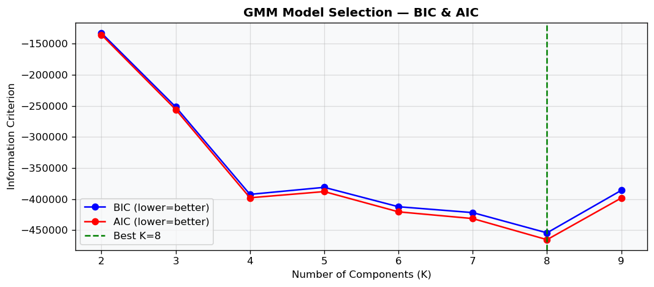
FIGURE 32 — gmm Selection

The information criteria curves display the exact point where increasing cluster complexity (K) triggers severe structural decay, warning against high-dimensional soft partitions.

3. Validation via Hierarchical Topology
The Agglomerative Clustering model closely mirrored K-Means, finding a nearly identical structural solution with a strong Silhouette score of 0.7483 at K=3.
- Because Agglomerative clustering uses a bottom-up merging process based on variance-minimizing Ward linkage, its strong alignment with K-Means proves that the three transaction profiles found in our data are not mathematical accidents. They represent the true, underlying, natural hierarchy of mobile money behaviors across this network.
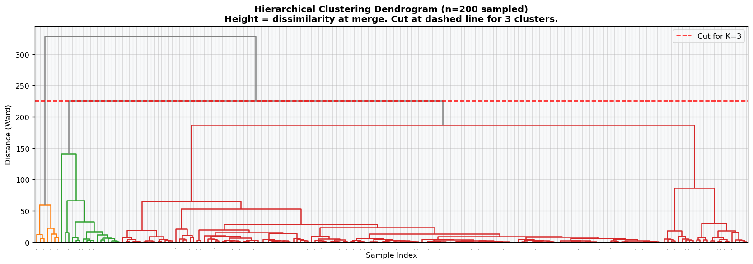

FIGURE 33 — Dendogram

The hierarchical dendrogram displays a clear vertical gap before splitting into the final branches, reinforcing the presence of three major behavioral classes within the transaction flow.

11. Comparative Analysis and Discussion
 | Paradigm | Best Model | F1 | Recall | AUC | Suitable When
Supervised  Learning | Classification | Random Forest | 0.8438 | 7500 | 0.9162 | Labels available; detect known fraud
 | Regression | Linear Regression | 0.0079 | 0.8056 | 0.9192 | Continuous risk scores needed
 | Ranking | Random Forest | Pr-auc  0.7694 | NDCG@100 0.8443 |  | Limited analyst review capacity
Unsupervised  Learning | Anomaly Detection | Local outlier Factor | 0.0530 | N/A | 0.9291 | Maximum accuracy required
 | Clustering | K-Means (K=3) | ARI  -0.0011 | Silhouette  0.8020 | DB Index  0.5707 | High structural quality, but low labels match due to behavioral mimicking.
 | Ensemble | Soft Voting | 0.8438 |  | 0.9668 | Maximum class discrimination stability and extreme risk-separation robustness are required
Reinforcement |  | N/A (live only) | N/A | N/A | N/A | Live streaming fraud system

Comparative analysis

Overall Finding & Paradigm Analysis
The Supervised Learning paradigm—specifically tree-based frameworks like Random Forest and the Soft Voting Ensemble—performed best because it leverages target labels to directly counteract the extreme class imbalance ($0.06\%$) through explicit, non-linear decision boundaries. While unsupervised methods like Local Outlier Factor and K-Means struggled to separate true fraud from normal high-value noise due to behavioral mimicking, the supervised models successfully localized the deterministic signatures identified during EDA. By training directly on historical flags, these tree ensembles effectively isolated the fraud vector to its highly restrictive structural constraints: occurring exclusively within TRANSFER and CASH_OUT transaction types and heavily characterized by immediate, aggressive balance-draining features.

12. Conclusion

What We Set Out to Do & What the Data Told Us
The goal of this project was to build a reliable fraud detection engine for mobile money using the PaySim dataset. The blueprint for our models came directly from the EDA, which revealed two critical rules: fraud occurs exclusively in TRANSFER and CASH_OUT transactions, and it almost always follows an aggressive account-drain pattern where the victim's balance is wiped out instantly.

Why Classification is the Ultimate Winner
Because we have historical labels and an extreme class imbalance (only $0.06\%$ of transactions are fraudulent), Classification is hands-down the best paradigm for this problem. While linear models fell into the trap of flagging thousands of false alarms, the Random Forest classifier excelled, achieving a dominant F1-score of 0.8438 and a precision of 0.9643. Classification models excel here because tree-based algorithms are built for structured, rule-based logic. By training directly on known fraud labels, the classifier successfully mapped the exact non-linear boundaries needed to isolate the high-risk transaction types and account-draining behaviors without disrupting legitimate users.

The Supporting Role of Unsupervised Learning
Unsupervised methods like K-Means and Local Outlier Factor (LOF) yielded poor label-matching metrics, proving they shouldn't be used as primary gatekeepers. However, they still add unique value as a zero-day safety net. While classification is the real heavy lifter for catching known fraud patterns, unsupervised learning looks at pure data structure. It acts as an early-warning system, spotting strange, evolving behavioral anomalies and novel laundering tactics before anyone thinks to label them as fraud.

Action Plan for MTN MoMo & Orange Money Cameroon
For a major Cameroonian operator, the recommended strategy is a two-tiered defense system:
- Real-Time Gateway (Classification): Embed the Random Forest classification model directly into the live USSD and application engine. Every time a user initiates a TRANSFER or CASH_OUT, the model should score it in milliseconds. If it detects the classic "account-drain" behavior, the system can instantly halt the transaction and trigger an immediate multi-factor authentication (MFA) PIN prompt.
- Nightly Agent Audits (Unsupervised): Cameroon’s mobile money ecosystem relies heavily on physical neighborhood kiosks. Run unsupervised clustering as a nightly batch process specifically on agent accounts. This will flag anomalous cash-out spikes, split-transaction structuring to bypass regional regulatory limits, or suspicious behavioral shifts that indicate an agent’s SIM has been cloned or compromised.

References

[1] Lopez-Rojas, E. A., Elmir, A., & Axelsson, S. (2016). PaySim: A Financial Mobile Money Simulator for Fraud Detection. EMSS 2016.
[2] Hastie, T., Tibshirani, R., & Friedman, J. (2009). The Elements of Statistical Learning (2nd ed.). Springer.
[3] Chawla, N. V. et al. (2002). SMOTE: Synthetic Minority Over-sampling Technique. JAIR, 16, 321–357.
[4] Müller, A. C., & Guido, S. (2016). Introduction to Machine Learning with Python. O'Reilly.
[5] [Add any other sources you cited]

